**LAPORAN FRAMEWORK PROGRAMMING**

**SISTEM INFORMASI SEKOLAH BERBASIS WEBSITE DENGAN MENGGUNAKAN LARAVEL**



**FRAMEWORK PROGRAMMING**

**Pada Program Studi DIV Teknik Informatika**

**Disusun Oleh :**

**Nama : Yolanda Iris Sugianto (16090158)**

**Kelas : 5A**

**POLITEKNIK HARAPAN BERSAMA**

**TEGAL**

**2019**

**Sistem Informasi Sekolah**

**Pengujian dengan White Box**

1. **FlowChart**

* Admin

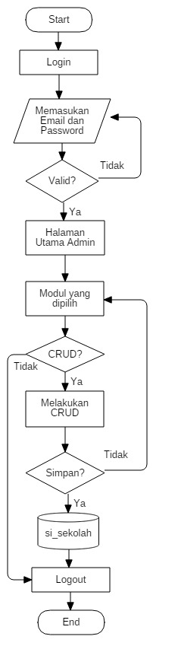

* User

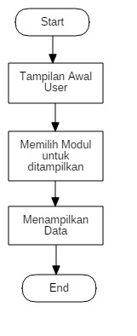

1. **CFG (Control Flow Graph)**

* Admin

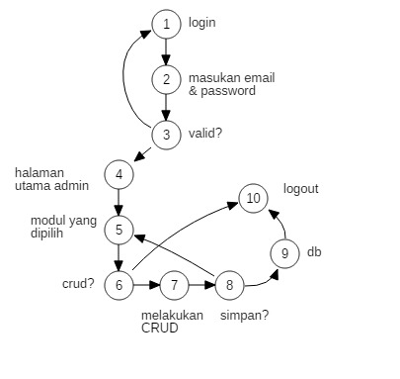

* User

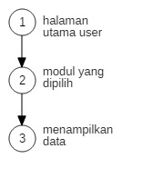

1. **Cyclomatic Complexity**

Rumus : V(G) = E – N + 2

* Admin

V(G) = 12 -10 +2

= 4

* User

V(G) = 2 – 3 +2

= 1

1. **Basic Path**

**Admin**

* Path 1 = 1-2-3-1
* Path 2 = 1-2-3-4-5-6-7-8-9-10
* Path 3 = 1-2-3-4-5-6-10
* Path 4 = 1-2-3-4-5-6-7-8-5-6-10

**User**

* Path 1 : 1-2-3

**Pengujian dengan Black Box**

1. Equivalence Partitioning

* Validasi untuk ukuran file gambar

|  |  |  |
| --- | --- | --- |
| Invalid | Valid | Invalid |
| …….,-1,0 | 1, 2 | 3, 4, …… |

* Validasi untuk memasukan judul berita yang panjang karakternya 70

|  |  |  |
| --- | --- | --- |
| Invalid | Valid | Invalid |
| …….,-1,0 | 1,2,3,…70 | 71, 72, …… |

* Validasi untuk memasukan isi berita yang panjang karakternya 500

|  |  |  |
| --- | --- | --- |
| Invalid | Valid | Invalid |
| …….,-1,0 | 1,2,3,…500 | 501, 502, …… |

* Validasi untuk memasukan NIS dan NIP yang panjang karakternya 10

|  |  |  |
| --- | --- | --- |
| Invalid | Valid | Invalid |
| …….,-1,0 | 1,2,3,…10 | 11, 12, …… |

* Validasi untuk memasukan nama yang panjang karakternya 50

|  |  |  |
| --- | --- | --- |
| Invalid | Valid | Invalid |
| …….,-1,0 | 1,2,3,…50 | 51, 52, …… |

* Validasi untuk memasukan kelas yang panjang karakternya 10

|  |  |  |
| --- | --- | --- |
| Invalid | Valid | Invalid |
| …….,-1,0 | 1,2,3,…10 | 11, 12, …… |

* Validasi untuk memasukan alamat yang panjang karakternya 100

|  |  |  |
| --- | --- | --- |
| Invalid | Valid | Invalid |
| …….,-1,0 | 1,2,3,…100 | 101, 102, …… |

* Validasi untuk tanggal lahir

|  |  |  |
| --- | --- | --- |
| Invalid | Valid | Invalid |
| …….,-1,0 | 1,2,3,…31 | 32, 33, …… |

* Validasi untuk masukan pengampu yang panjang karakternya

|  |  |  |
| --- | --- | --- |
| Invalid | Valid | Invalid |
| …….,-1,0 | 1,2,3,…50 | 51, 52, …… |

1. Tabel Kebenaran

* Validasi untuk login

|  |  |  |  |  |
| --- | --- | --- | --- | --- |
| Email | F | F | T | T |
| Password | F | T | F | T |
|  | error | error | error | berhasil |

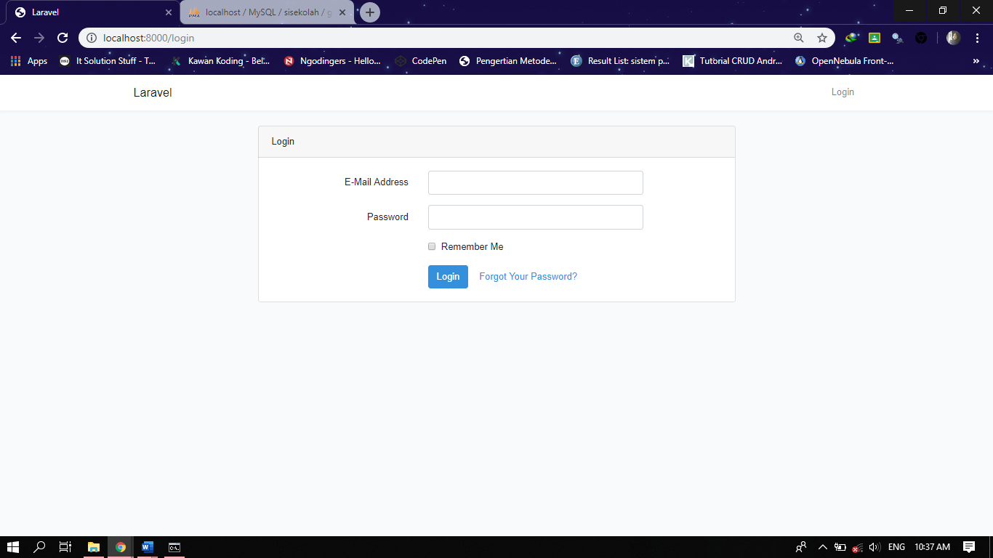

* 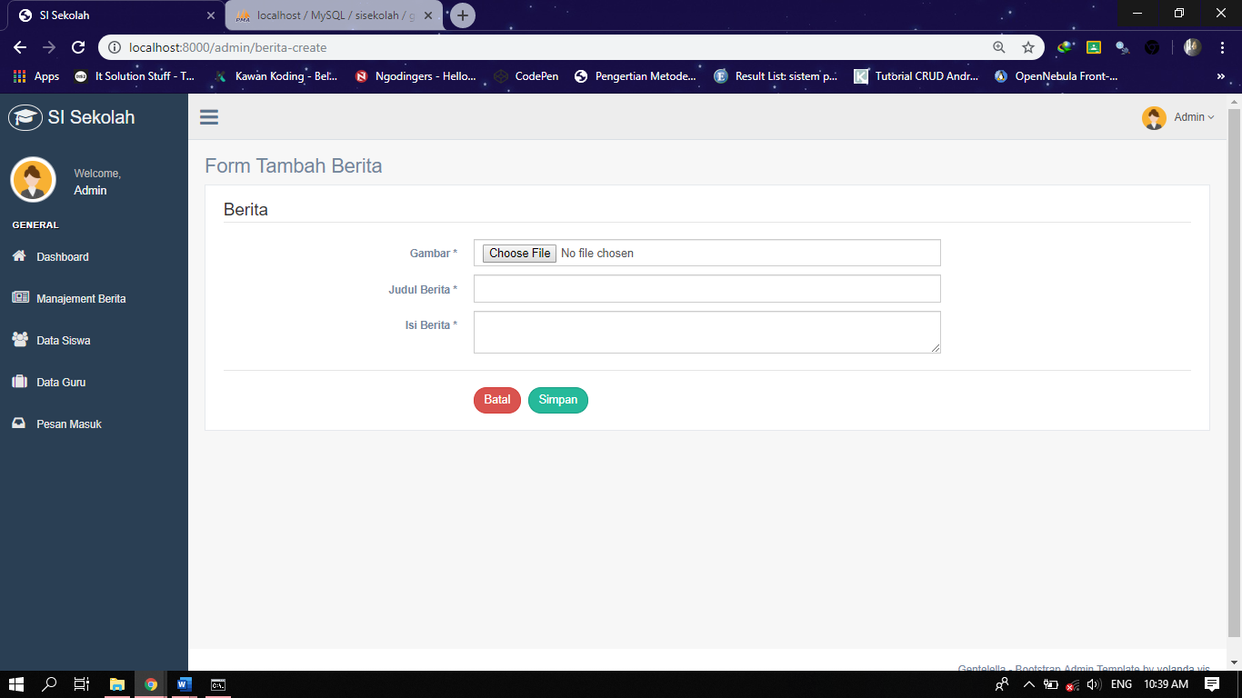Validasi untuk tambah berita

|  |  |  |  |  |  |  |  |  |
| --- | --- | --- | --- | --- | --- | --- | --- | --- |
| Judul | T | T | F | F | F | T | F | T |
| Isi | T | F | F | T | F | F | T | T |
| Gambar | F | F | F | F | T | T | T | T |
|  | error | error | error | error | error | error | error | berhasil |

* 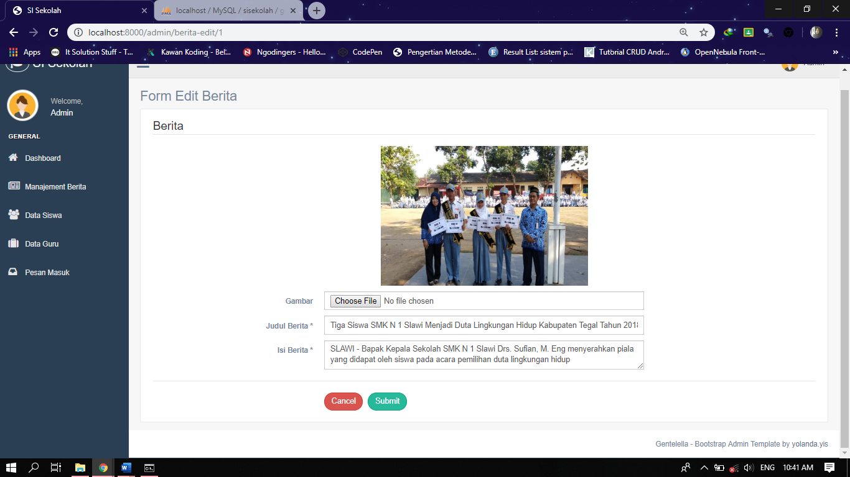Validasi untuk edit berita

|  |  |  |  |  |  |  |  |  |
| --- | --- | --- | --- | --- | --- | --- | --- | --- |
| Judul | T | T | F | F | F | T | F | T |
| Isi | T | F | F | T | F | F | T | T |
| Gambar | F | F | F | F | T | T | T | T |
|  | berhasil | error | error | error | error | error | error | berhasil |

* 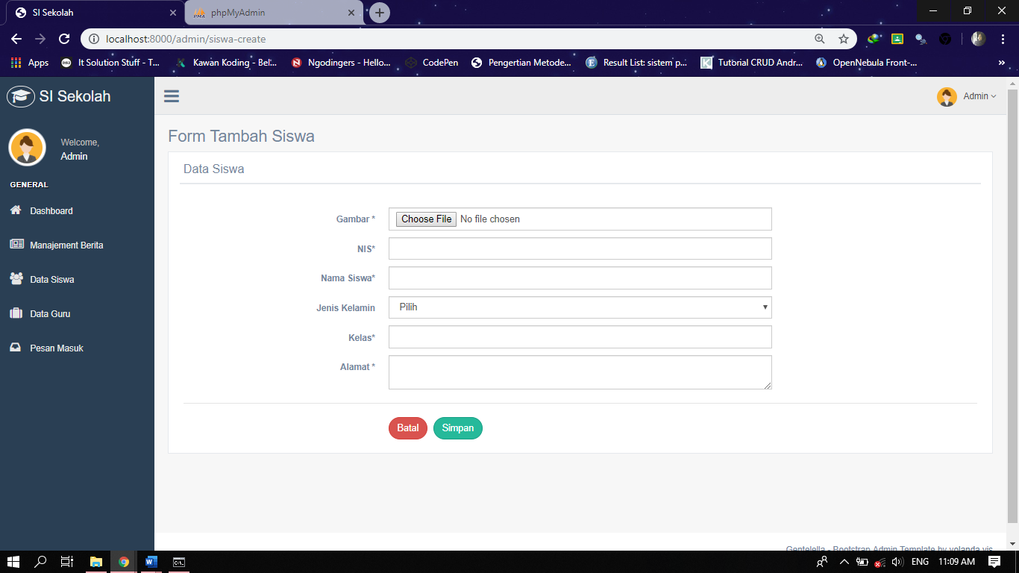Validasi untuk tambah data siswa

|  |  |  |  |  |  |  |
| --- | --- | --- | --- | --- | --- | --- |
| Alamat | T | T | T | T | T | T |
| NIS | - | T | T | T | T | T |
| Nama | - | - | T | T | T | T |
| JK | - | - | - | T | T | T |
| Kelas | - | - | - | - | T | T |
| Gambar | - | - | - | - | F | T |
|  | error | error | error | error | error | berhasil |

* Validasi untuk edit data siswa

|  |  |  |  |  |  |  |
| --- | --- | --- | --- | --- | --- | --- |
| Alamat | T | T | T | T | T | T |
| NIS | - | T | T | T | T | T |
| Nama | - | - | T | T | T | T |
| JK | - | - | - | T | T | T |
| Kelas | - | - | - | - | T | T |
| Gambar | - | - | - | - | F | T |
|  | error | error | error | error | berhasil | berhasil |

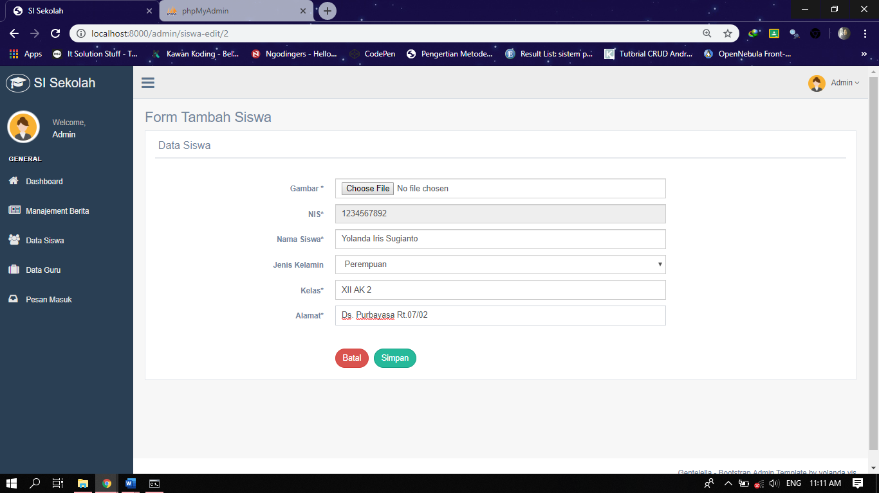

* Validasi untuk tambah data guru

|  |  |  |  |  |  |  |  |
| --- | --- | --- | --- | --- | --- | --- | --- |
| Kelas | T | T | T | T | T | T | T |
| NIS | - | T | T | T | T | T | T |
| Nama | - | - | T | T | T | T | T |
| JK | - | - | - | T | T | T | T |
| Tanggal Lahir | - | - | - | - | T | T | T |
| Tempat Lahir | - | - | - | - | - | T | T |
| Gambar | - | - | - | - | - | F | T |
|  | error | error | error | error | error | error | berhasil |

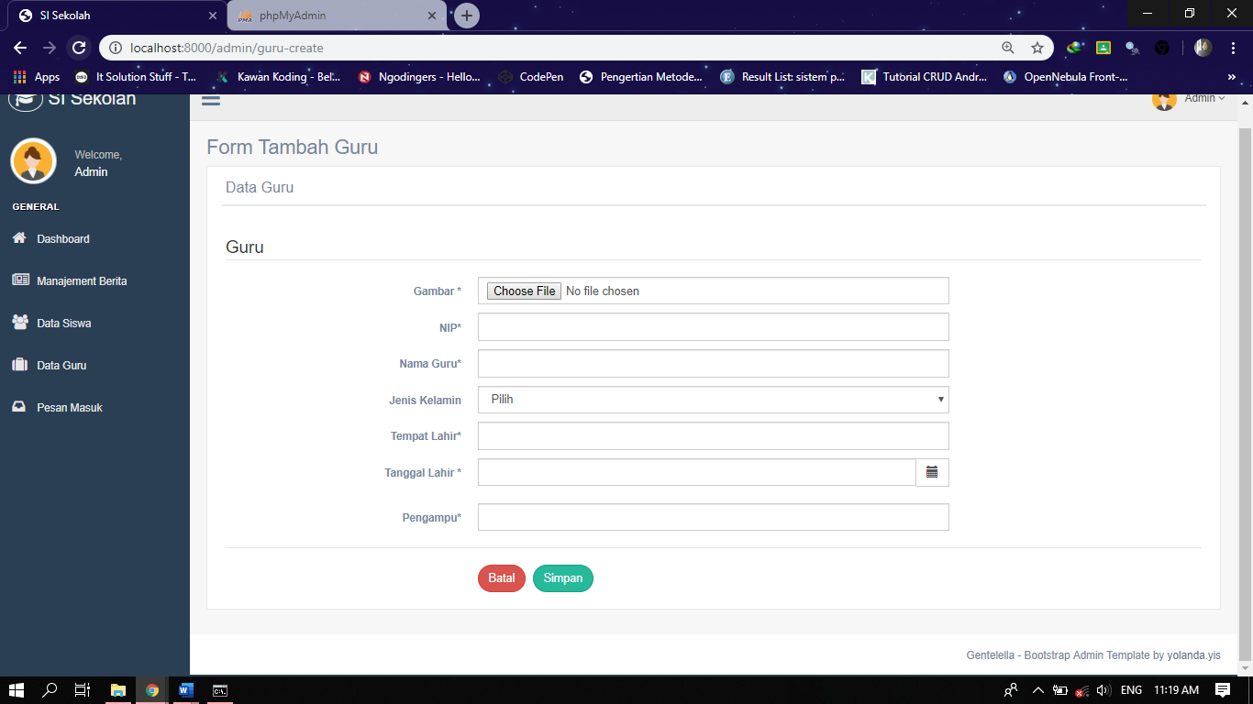

* Validasi untuk edit data guru

|  |  |  |  |  |  |  |  |
| --- | --- | --- | --- | --- | --- | --- | --- |
| Kelas | T | T | T | T | T | T | T |
| NIS | - | T | T | T | T | T | T |
| Nama | - | - | T | T | T | T | T |
| JK | - | - | - | T | T | T | T |
| Tanggal Lahir | - | - | - | - | T | T | T |
| Tempat Lahir | - | - | - | - | - | T | T |
| Gambar | - | - | - | - | - | F | T |
|  | error | error | error | error | error | berhasil | berhasil |

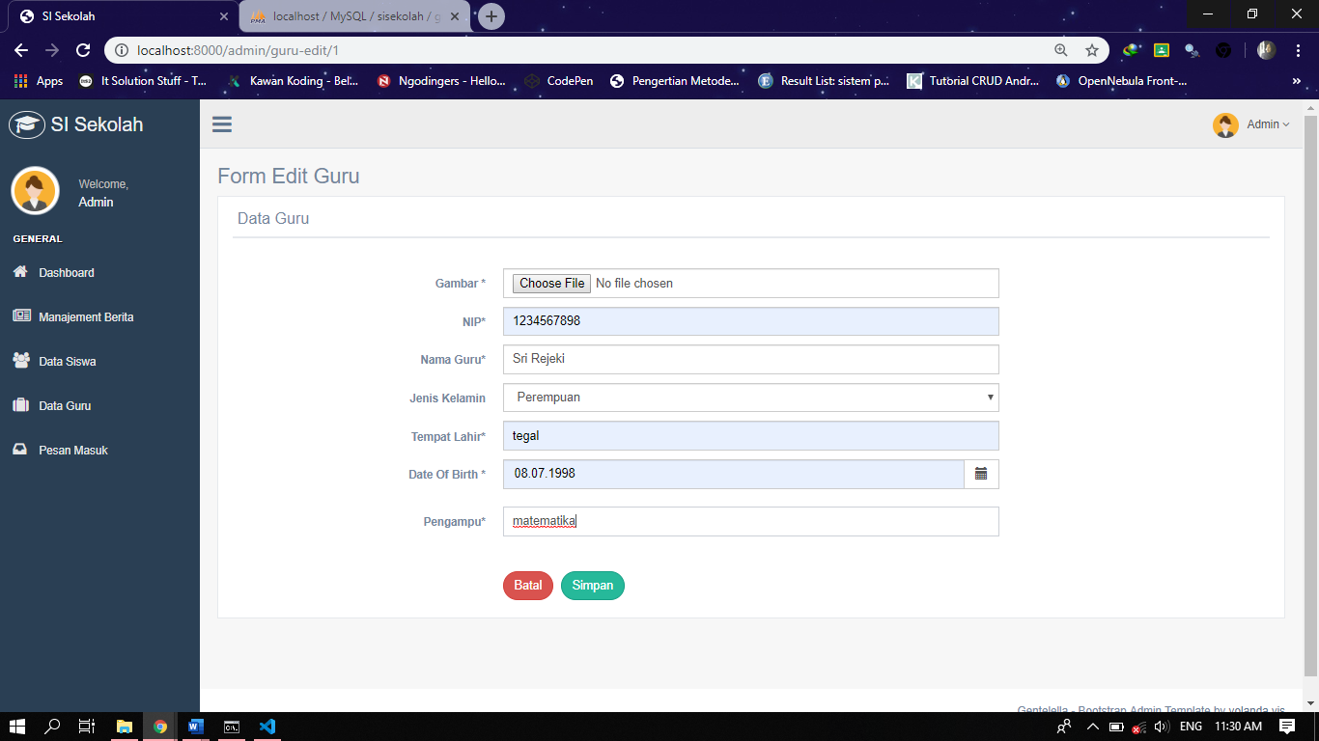

* Validasi untuk kritik dan saran

|  |  |  |  |  |  |  |  |  |
| --- | --- | --- | --- | --- | --- | --- | --- | --- |
| Nama | T | T | F | F | F | T | F | T |
| Email | T | F | F | T | F | F | T | T |
| Isi Pesan | F | F | F | F | T | T | T | T |
|  | error | error | error | error | error | error | error | berhasil |

